# Strategy

## Problem statement

The access to banking services is restricted to bank hours affecting most of our bank customers by having to wait to the next business day, adding more staff or hours, or finding another solution. Our solution will allow the bank to provide services at any hour and in locations where a bank branch is not located reducing overhead costs. Replacing teller and not having bank open with automation of transaction external to bank reduces overhead and improves customer experience.

## Constraints

Infrastructure, technology, laws, etc.

## Stakeholders

I. Hafmunee – Bank President

Gee Kee Tekhed – CIO of bank

# Analysis – high level

## Actors

* Customer
* Operator

## Use case names

### System use cases

* Transfer funds
* Check balance
* Withdraw cash
* Deposit funds

### Business use cases

* Reload machine cash
* Reload receipt paper
* Retrieve cards
* Reset machine
* Do routine maintenance on machine

## Grouped names - system

* Do Secure Session – authorize with only an ATM card
* Do Customer Transaction - transfer, balance, withdraw and deposit

## Grouped names - business

* Do Secure Session with Key – authorize with key and special ATM card
* Do Maintenance – reload cash, paper, get cards, reset, and other maintenance.

# Project management

## User stories

* As a customer, I want to **get cash** so that I can go buy merchandise and services
* As an account holder, I want to **check my balance**, so I can keep from getting overdrawn.
* As a customer, I want to **transfer money** from savings to checking so that I keep a minimum balance.
* As a bank account holder, I want to **deposit checks** I receive so I can use the money quickly.

## Prioritization

|  |  |  |  |  |
| --- | --- | --- | --- | --- |
| User stories | Business /  Market  usage %  (3=100-67  2= 66-34, 1=0-33%) | Business / pricing value  (3=exec/high,  2=mgmt./med.  1=staff/low) | Result = usage * value | Group summary:  ask for the top 3 and  count the  total. |
| Get cash | 3 | 3 | 9 | 5 |
| Check balance | 1 | 1 | 1 | 2 |
| Transfer money | 2 | 1 | 3 | 2 |
| Deposit checks | 3 | 2 | 6 | 5 |

## Project Iterations

### set up

### 1st

Get Cash

### 2nd

Deposit Checks

### 3rd

Transfer money

Check balance

# Analysis documents

## Use Cases

### Summary of all use cases

#### Grouped use cases

* G-ATM1 - Do Secure Session
  + Wrapper for all secure transactions with ATM card with printing of receipt
* GATM.P1+1 - Do Customer Transaction
  + allows use cases for customers only
* G-ATM2 - Do Secure Session with key
  + Wrapper for all secure transactions with ATM card with printing of receipt
* GP-ATM2+1 - Do Maintenance
  + allows use cases for maintenance only

#### System use cases

* ATM.P1+1a - Withdraw cash
  + A customer swipes bank card, asks for cash, gets approved, receives and receipt.
* ATM.P1+1b - Deposit Funds
  + description
* ATM.P1+1c- Transfer funds
  + description
* ATM.P1+1d - Check balance
  + description

#### Business use cases

* P-ATM2+1a - Reload machine cash
  + description
* P-ATM2+1b - Reload receipt paper
  + description
* P-ATM2+1c - Retrieve cards
  + description
* P-ATM2+1d - Reset machine
  + description
* P-ATM2+1e - Do routine maintenance on machine
  + description

# Use Case Details

## ATM.G1 - Do Secure Session

### General info

**Description**: Wrapper for all secure transactions with ATM card for selection of menu options and printing of receipt

**Actors**: Customer

**Supporting roles/systems**: Bank

**Type**: System

### Scope info

**Level**: Group of goals

**Includes**: ATM.G1+GP1 -Do Customer Transaction

**Diagram**:

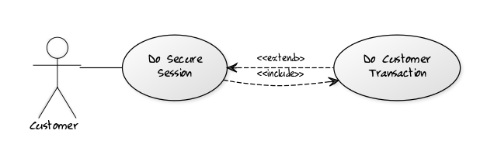

[Customer]-(Do Secure Session),

(Do Secure Session) > (Do Customer Transaction),

(Do Secure Session) < (Do Customer Transaction)

### Tracking info

**Author** – BA class

**Date created** – 6/16/17

**Date revised** – 3/20/2018

### Project info

**Design constraints**: Strongbox Platinum3 ATM chassis, OS 2.3

**Priority**: 5

**Value to sponsor**: Reduce overhead costs by offering a similar automated process to what teller does.

**Sponsor**: Bank President

### Course of Events

1. The use case starts when the actor inserts their bank **card**\*.
2. The system checks the card. The system prompts for **PIN**\* (D#?). The actor enters PIN.
3. The system requests bank to validate user and retrieves all **account information\*** for that user.
4. The system makes a bank communication **log entry\***.
5. The system prompts the actor with a main menu (D#2).
6. **<<include>> ATM.G1+GP1 Do Customer Transaction**
7. The system prompts user for another transaction (D#?). The actor declines.
8. The system prints receipt. The system prompts the user to take receipt. The actor takes the receipt.
9. The system ejects the card. The system prompts the user to take card, receipt and thank-you (D#?). The system starts a timer. The actor takes the card. The system stops the timer.
   1. **RULE** – Card eject timer limit – 15 seconds after prompt is given.
10. The system returns to idle state (D#1) after a transaction end delay
    1. **RULE** – Transaction end delay – 15 seconds after last keystroke/activity until new screen appears

### Alternate flows (errors, exceptions)

* **Card is invalid** (2) – The system ejects the card and prompts the user with an invalid card message (D#?). The actor takes the card. The system continues at #10.
* **Cancel key pressed** (#2,7) – The system prompts for confirmation (D#?). The actor confirms. The system continues at #8.
* **Card not taken** (#9a) – The system will retain the card after the timer limit and then prompt the user with information on how to get card back (D#?) The system continues at #10.

### Alternate flows (extension points)

* **Another transaction** (#7) The system continues at #5.

### Post-conditions

* Bank communication has been recorded

### Notes/ Special Requirements

* Lighting around ATM must always be equal to or greater than 80 lux (office hallway).
* Receipt must be able to stay in machine with 30mph wind.

## ATM.G1+GP1 - Do Customer Transaction

### General info

**Description**: After customer has been authorized with a bank card, they will be able to do any of these secure transactions.

**Actors**: Customer

**Supporting roles/systems**: Bank

**Type**: System

### Scope info

**Level**: group of partial goals

**Included in**: ATM.G1 - Do Secure Session

**Use cases grouped by this ID**:

* ATM.G1+GP1a - Withdraw cash
* ATM.G1+GP1b - Deposit Funds
* ATM.G1+GP1c- Transfer funds
* ATM.G1+GP1d - Check balance

Diagram:

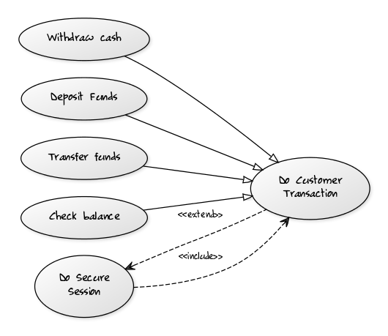

(Withdraw cash)^(Do Customer Transaction),

(Deposit Funds)^(Do Customer Transaction),

(Transfer funds)^(Do Customer Transaction),

(Check balance)^(Do Customer Transaction),

(Do Secure Session) > (Do Customer Transaction),

(Do Secure Session) < (Do Customer Transaction)

### Tracking info

**Author** – BA class

**Date created** – 6/16/17

**Date revised** – 3/20/2018

### Project info

same as ATM.G1 - Do Secure Transaction

## ATM.G1+GP1a – Withdraw Cash

### General info

**Description**: Actor gets requested cash and receipt

**Actors**: Customer

**Supporting roles/systems**: Bank

**Type**: System

**Pre-conditions:** Cash in machine must be equal to or greater than **Maximum Amount of Withdrawal** (R#1)

### Scope info

**Level**: Partial goal

**Grouped by**: ATM.G1+GP1 Do Customer Transaction

**Diagram**:

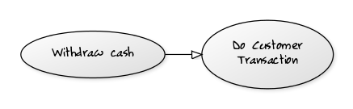

(Withdraw cash)^(Do Customer Transaction)

### Tracking info

**Author** – BA class

**Date created** – 6/16/17

**Date revised** – 3/20/2018

### Project info

same as ATM.G1 - Do Secure Transaction

### Course of Events

1. The use case starts when the actor selects Withdraw Cash from menu.
2. The system prompts actor for account to use (D#?). The actor selects account.
3. The system prompts actor for withdrawal amount (D#?). The actor enters amount.
4. The system prompts actor to wait while transaction is processing (D#?). The system validates withdrawal amount requested.
   1. **RULE** – Sufficient funds – Amount requested must be less than or equal to account balance.
   2. **RULE** – Daily withdrawal limit – Amount requested must be less than or equal to $1000 per day starting at midnight local time and not available until the next 24 hour period.
   3. **RULE** – Transaction withdrawal limit – Amount requested must be less than or equal to $400.
   4. **RULE** – Withdrawal increments - $20 increments
5. The system prompts actor to confirm amount (D#?). The actor confirms amount.
6. The system requests bank to update account with the withdrawal **transaction**\*. The bank confirms update. The system makes a **log entry**\* for the communication.
7. The system decrements cash in **ATM**\*. The system dispenses cash. The system makes a **log entry**\* for the withdrawal. The system prompts actor to take cash (D#?). The system starts a timer. The actor takes cash. The system stops timer.
   1. **RULE** – Cash dispensed in machine time – 15 seconds.

### Alternate flows (errors, exceptions)

* **Insufficient funds** (4a) – The system prompts user to use a smaller withdrawal amount or cancel. The use case continues at #3.
* **Daily withdrawal amount reached** (4b)
* **Transaction withdrawal amount exceeded** (4c)
* **Withdrawal increment incorrect** (4d)
* **Cash not taken** (7)

### Post-conditions

* Bank communication has been recorded
* Transaction has been recorded

### Notes/ Special Requirements

* Cash must be able to stay in machine with 30mph wind.

# Data Dictionary (separate file)

* Account information
  + Card*
  + Number
  + Balance
    - **RULE** – in US dollars
  + Available funds
    - **RULE** – in US dollars
  + PIN – digits to authorize users’ bank cards stored by bank system
    - **RULE** – max 8 digits
* Card
  + Number
  + Bank
    - **RULE** –Must be this bank or member bank.
* ATM
  + Cash in machine
    - **RULE** – in US dollars
* **Log entry –** bank communication, cash withdrawal
  + Account information*
  + PIN info – never recorded.
* Receipt information
  + Account information*
  + Current date and time
* Transaction
  + Account information*
  + Amount
    - **RULE** – in US dollars
  + Type
    - **RULE** – one of Withdrawal, Deposit, Transfer, or Inquiry
  + Date / time

# Rules (separate file)

Reusable rules referenced in multiple use cases. Referenced by R#1, R#2, etc.

R#1 – **Maximum Amount of Withdrawal** = $200 by default with ability to modify by customer through representative or self-service web site.

# Text (separate file)

T#1 –Please enter your PIN.

T#2 – No, not that one.

T#3 - Please take card and thanks for stopping by.

T#4 – Try again.

# Reports (separate file)

R#1 – receipt

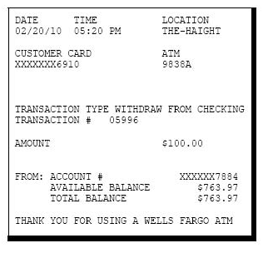

# Designs (separate file)

D#1 – Welcome/splash screen

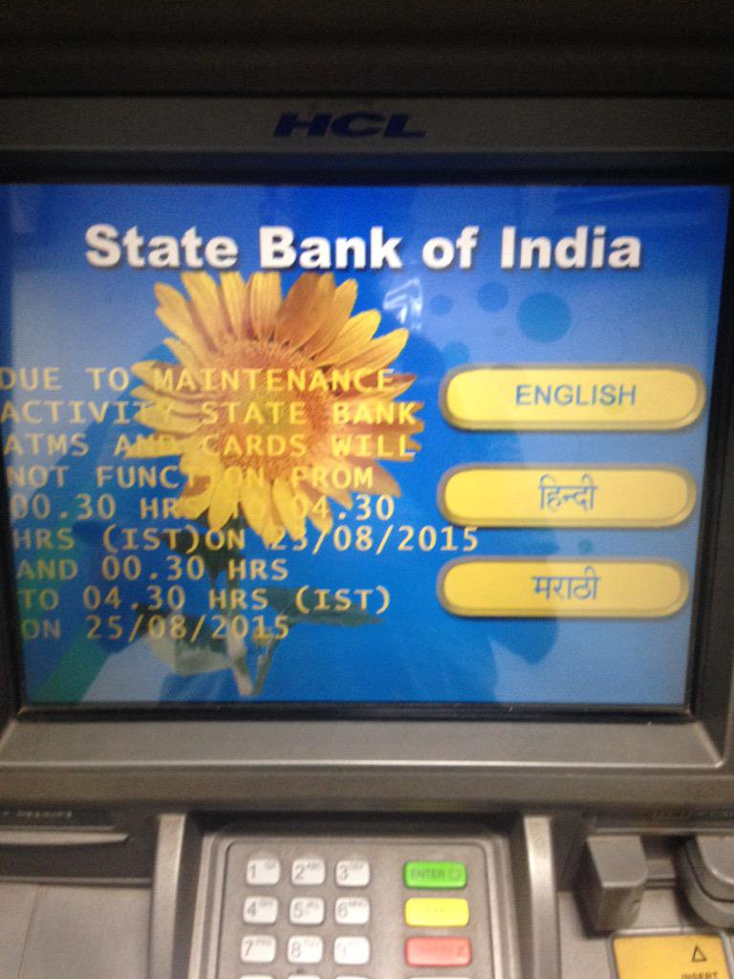

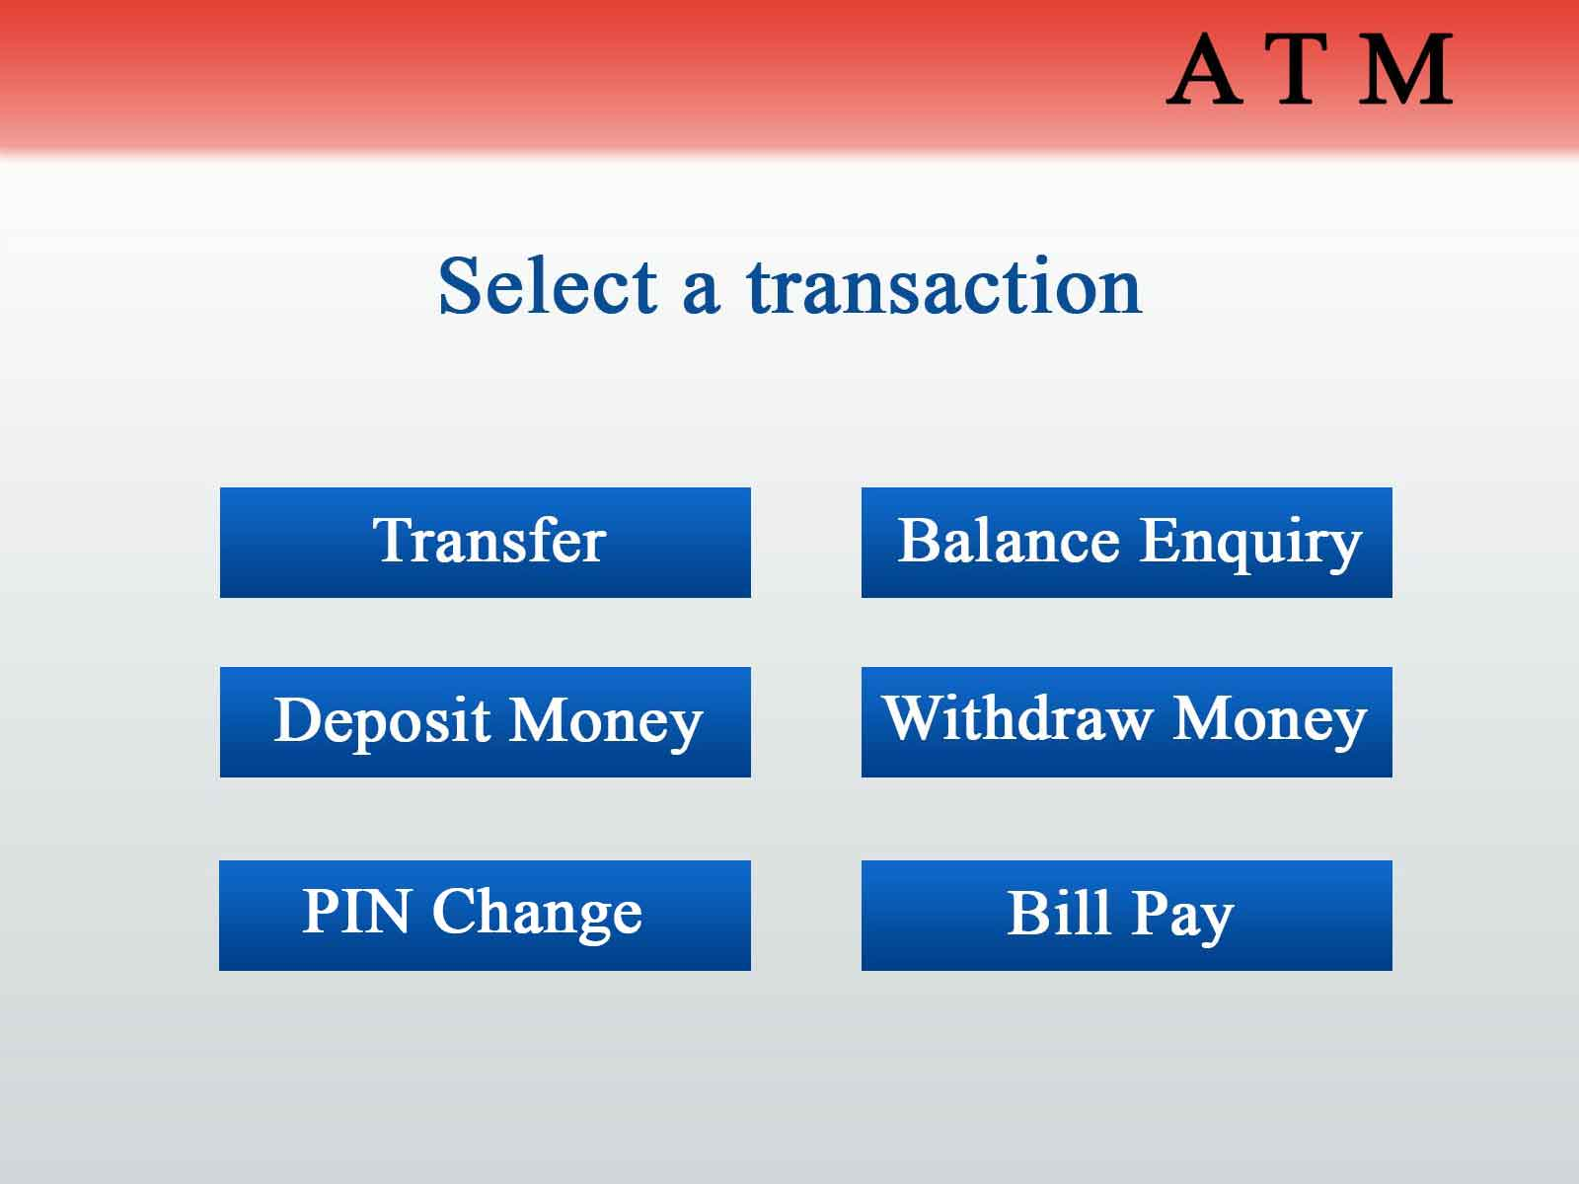D#2 – Main menu

# Glossary (separate file)

|  |  |
| --- | --- |
| **ATM** | Automated Teller Machine |
| **Bank** | the bank |
| **Customer** | anyone with a bank card |